Lab 7: Training a Cancer Diagnosis Agent with DT

Brandon Trinkle

Arizona State University

Course Number: IFT 360

Professor Durgesh Sharma

9/22/24

**Question 1:** *Run the code. What does it print?*

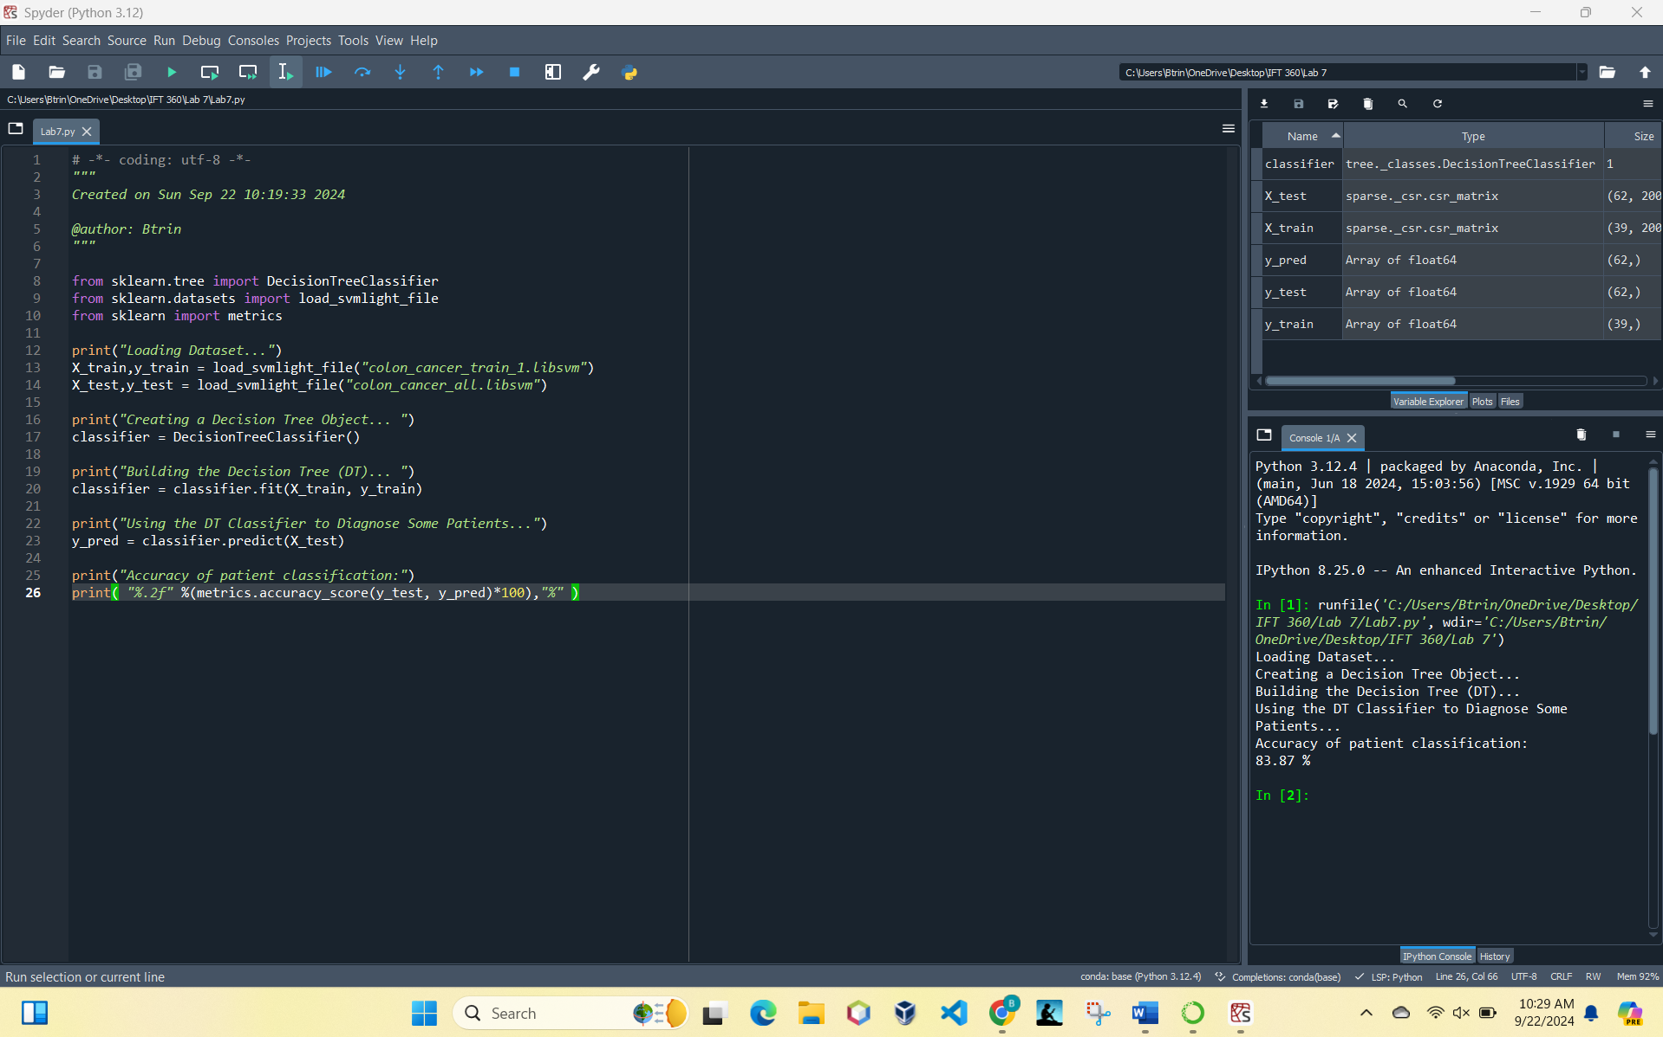

Print output:

* Loading Dataset...
* Creating a Decision Tree Object...
* Building the Decision Tree (DT)...
* Using the DT Classifier to Diagnose Some Patients...
* Accuracy of patient classification:
* 83.87 %

**Question 2:** *What is the obtained classification accuracy*

The obtained accuracy was 83.87%.

**Question 3:** *Do you think this accuracy is good or bad?*

Since this is a binary classification problem (presence of colon cancer vs. absence of colon cancer), an accuracy of 50% would be equivalent to random guessing if the classes are balanced. Therefore, anything significantly above 50% indicates that the model is learning something useful. In medical diagnosis, the consequences of false negatives (predicting no cancer when cancer is present) and false positives (predicting cancer when it's absent) are serious. In this case, you would typically want a high accuracy to ensure that patients are correctly diagnosed. Finally, the accuracy obtained (83.87%) is fairly good but not excellent for a medical diagnosis application. It suggests the model is performing reasonably well but still has room for improvement.